**Blockchain Lab Experiment 4**

**Shashwat Tripathi**

**D20A Roll No: 64**

**Aim:** Implement the Blockchain platform Ganache.

**Practical: Case Study on Central Bank Digital Currency(CBDC)**

**Code:**

// SPDX-License-Identifier: MIT

pragma solidity ^0.8.0;

contract CBDC {

string public name = "Central Bank Digital Currency";

string public symbol = "CBDC";

uint8 public decimals = 18;

uint256 public totalSupply;

mapping(address => uint256) public balanceOf;

mapping(address => mapping(address => uint256)) public allowance;

address public centralBank;

event Transfer(address indexed from, address indexed to, uint256 value);

event Approval(address indexed owner, address indexed spender, uint256 value);

event Mint(address indexed to, uint256 value);

event Burn(address indexed from, uint256 value);

modifier onlyCentralBank() {

require(msg.sender == centralBank, "Only central bank can execute this");

_;

}

constructor(uint256 _initialSupply) {

centralBank = msg.sender;

mint(centralBank, _initialSupply);

}

function mint(address _to, uint256 _amount) public onlyCentralBank {

totalSupply += _amount;

balanceOf[_to] += _amount;

emit Mint(_to, _amount);

emit Transfer(address(0), _to, _amount);

}

function burn(uint256 _amount) public onlyCentralBank {

require(balanceOf[centralBank] >= _amount, "Insufficient balance");

balanceOf[centralBank] -= _amount;

totalSupply -= _amount;

emit Burn(centralBank, _amount);

emit Transfer(centralBank, address(0), _amount);

}

function transfer(address _to, uint256 _amount) public returns (bool success) {

require(balanceOf[msg.sender] >= _amount, "Insufficient balance");

balanceOf[msg.sender] -= _amount;

balanceOf[_to] += _amount;

emit Transfer(msg.sender, _to, _amount);

return true;

}

function approve(address _spender, uint256 _amount) public returns (bool success) {

allowance[msg.sender][_spender] = _amount;

emit Approval(msg.sender, _spender, _amount);

return true;

}

function transferFrom(address _from, address _to, uint256 _amount) public returns (bool success) {

require(balanceOf[_from] >= _amount, "Insufficient balance");

require(allowance[_from][msg.sender] >= _amount, "Allowance exceeded");

balanceOf[_from] -= _amount;

balanceOf[_to] += _amount;

allowance[_from][msg.sender] -= _amount;

emit Transfer(_from, _to, _amount);

return true;

}

}

Installing Ganache on Windows

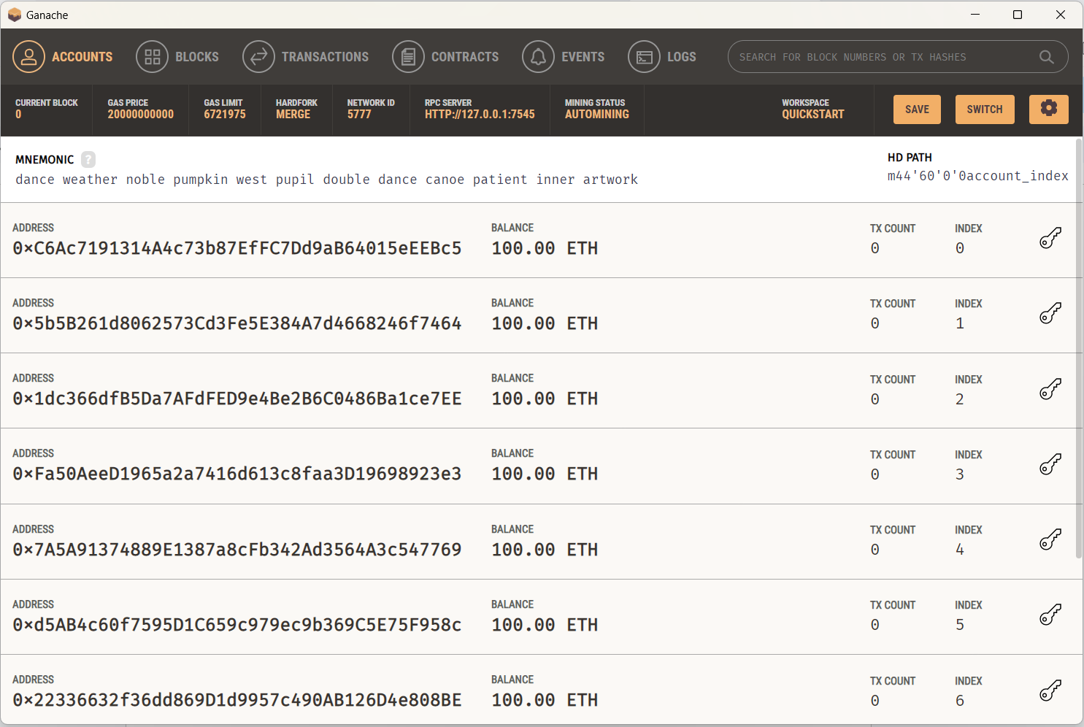

Setting up the Ganache network on Metamask

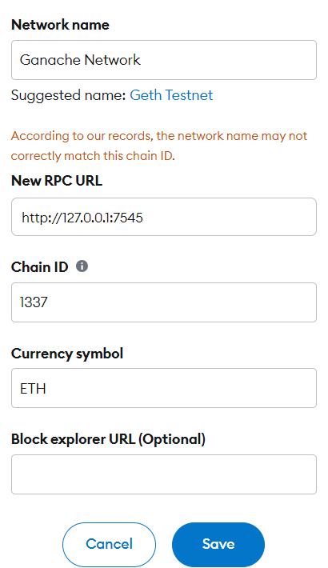

Copy the private key from the Ganache account and paste it into the Metamask.

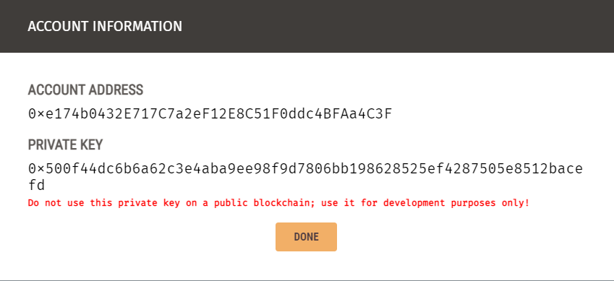

Importing the Ganache account on the Metamask by entering the private key.

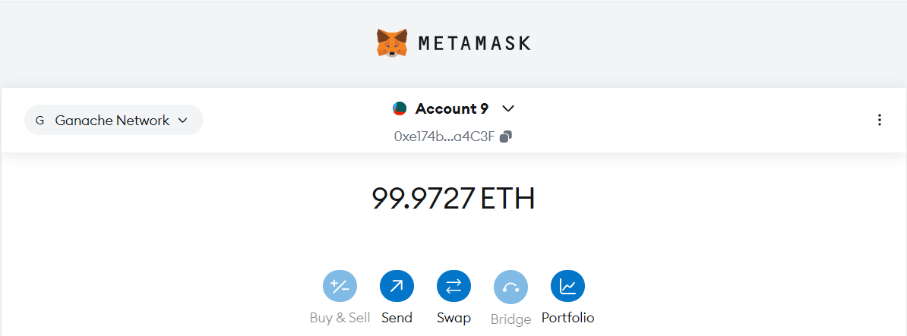

Compile the solidity contract

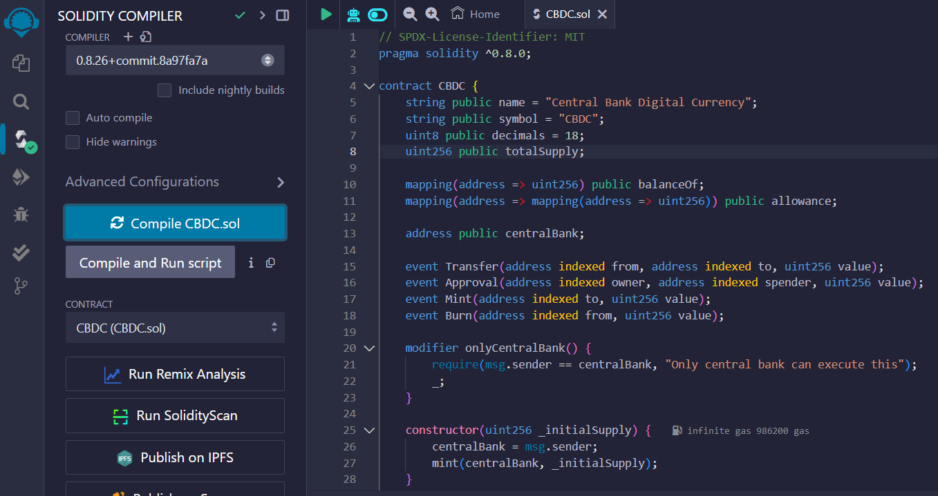

Deployed the contract with central bank account.

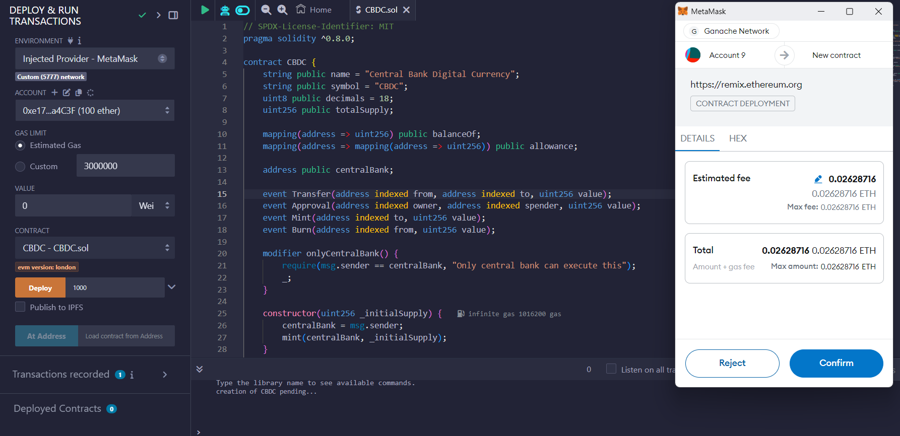

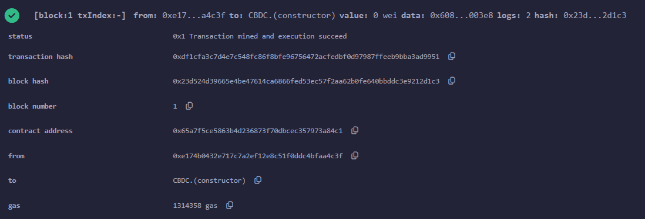

Owner now has 1000 coins

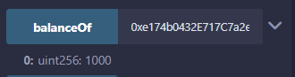

Sending 50 coins to other address

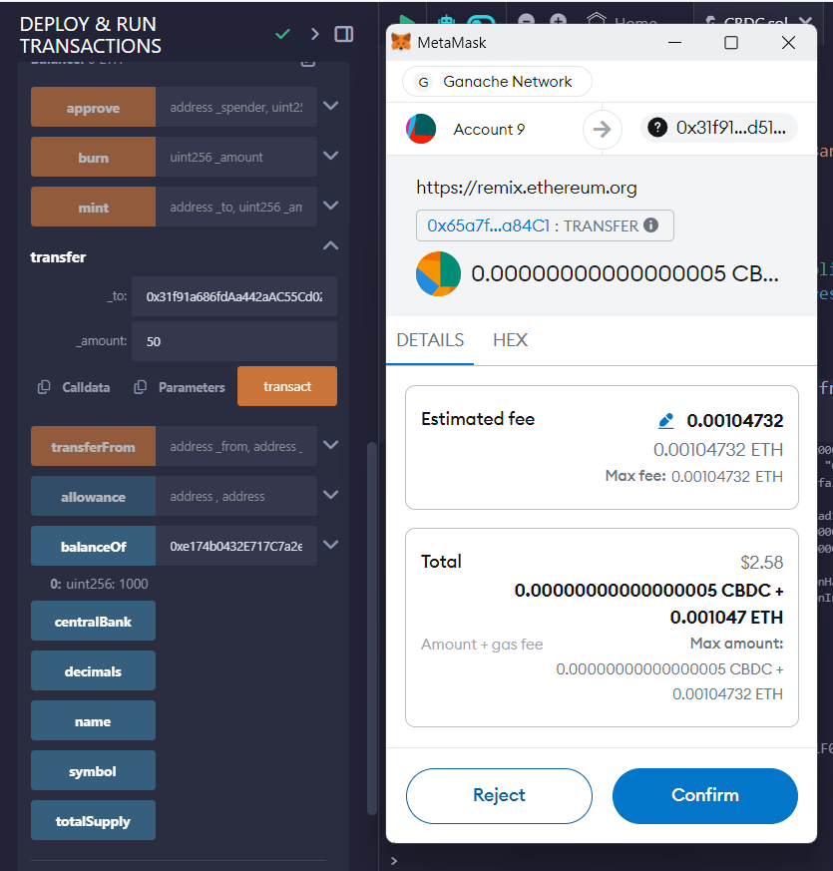

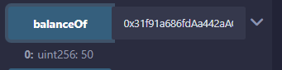

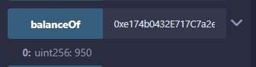

Verifying the transactions in the Ganache

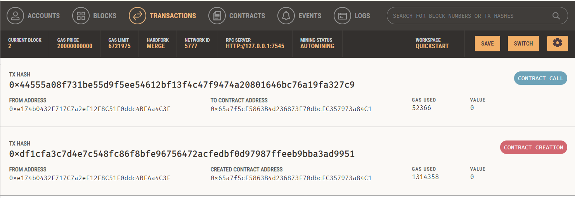

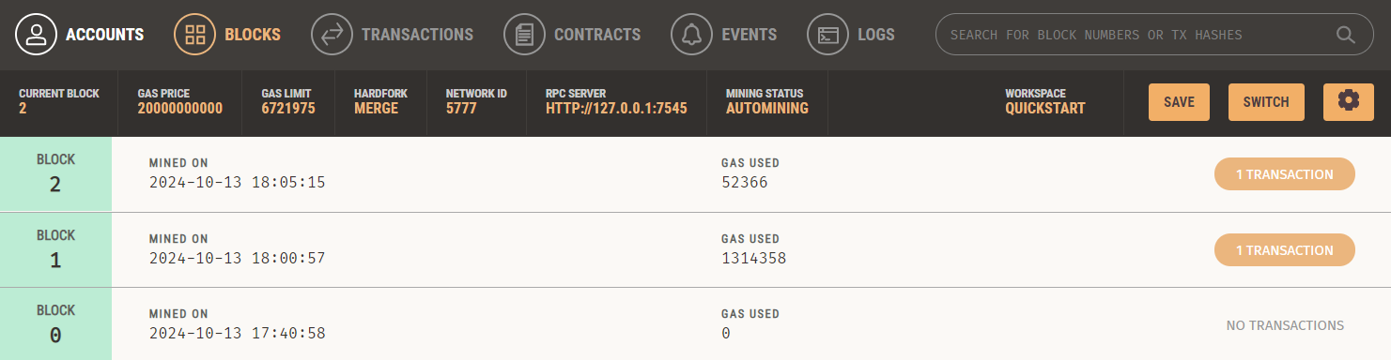

Conclusion: Thus we have set up the Ganache platform and executed the contract for Central Bank Digital Currenct(CBDC) and successfully verified.